Biology/Medicine/Public Health Team

Morgan Godley, Priom Mahmud, Qin Xu, Chaobo Yan

MATH/STAT 571B

5/15

*Meditation vs Walking: A Factorial Study on Mood Change*

*Report*

**Abstract:**

**Introduction:**

We will investigate how effectively meditation and walking, two common well-being practices, influence mood change. Both activities are widely recommended for improving mental health, and it would be valuable to measure which has a stronger impact on mood. This is an important topic of study because meditation and walking are both free and time-efficient activities that can be easily incorporated into daily routines for improving our everyday mental wellness.

Our response variable is the mood-change, defined as the difference between post-activity-mood and pre-activity-mood scores. The two factors in our design are:

1. Activity (5-minute meditation vs. 5-minute walk), treated as a fixed treatment factor
2. Time of Day (morning vs. Afternoon), treated as a fixed effect. We included Time of Day as a factor based on the theory that mood may be more responsive to change depending on whether the activity happens in the morning or afternoon.

We also included User (team member) as a random-effect blocking factor, assuming individuals may respond differently to treatments.

We conducted a 22 factorial design and explored the following research questions:

1. Which activity, meditation or walking, has a stronger effect on mood?
2. Does time of day influence mood improvement?
3. Is there an interaction between activity type and time of day?

We will measure our results using a linear mixed-effects model:

lmer(Score ~ Time * Activity + (1|User))

This will test for both main effects and their interaction while accounting for user-level variability.

**Experiment Design:**

We performed a full 22 factorial design.

Each team member performed a morning & afternoon 5-minute meditation as well as a morning & afternoon 5-minute walk. Each treatment condition was repeated 4 times, to fit the requirements of a 22 factorial design. Because each team member runs their experiments independently (without telling each other) and in random order, this ensures that the design has independence among samples and full randomization. The end result is a balanced and fully replicated design.

For our response variable, change in mood, every teammate self-reported their mood both before their activity as well as 10-25 minutes after the activity. The difference between post-activity-mood and pre-activity mood (change in mood) was recorded as our response variable. To minimize bias while self-reporting our moods, we leveraged a tool called Affect Grid (AGRID). AGRID creates a composite mood score by combining the emotional and physical dimensions into a single metric (Russell et al., 1989).

A 22 factorial design (please see appendix for full design table) was ideal for our study for several reasons. The factorial design allowed us to test two factors (Activity and Time) at two levels each, while also capturing any potential interaction effects, on mood change. Unlike a one-factor-at-a-time (OFAT) approach, the factorial design allowed us to efficiently evaluate both main effects and interactions, using fewer runs. In short, the 22 factorial design was appropriate because it provided a compact yet powerful way to explore multiple scenarios with minimal repetition burden to each participant.

To evaluate the sensitivity of our experiment, we conducted a power analysis based on our 22 factorial design with 64 total observations, resulting in 16 observations per each of our 4 treatment groups. Assuming a standard deviation of 2 in mood scores, our design achieved 91.67% power to detect a 1-point difference in mean mood change (please see appendix for power of test). This means we have strong sensitivity to moderate effects. This was calculated using a Power Anova Test, please see R code. For larger differences, such as 3 or 5 points, power approached 100%, meaning our study was virtually guaranteed to detect large mood changes. However, for very small mood changes, such as 0.1, the power was just 5.89%, suggesting that our experiment struggled to detect subtle effects. Overall, the design had sufficient power to detect moderate to large effects.

**Statistical Analysis**

Our main model concerned is the following:

$$y_{ijk}=μ+τ_{i}+β_{j}+{\left(τβ\right)}_{ij}+γ_{k}+ϵ_{ijk}$$

where $μ$ is the overall mean, $τ_{i}$ is the $i$ th level of activity (walking and meditation), $β_{j}$ is the $j$ th level of time (morning and afternoon) and $γ_{k}$ is the $k$ th team member. $ϵ_{ijk}∼N\left(0,σ_{ijk}^{2}\right)$ is the random error.

The above design and statistical model can lead to the following test hypothesis:

$H_{0} :$ The mean change of mood before/after taking the activity is the same. $H_{a} :$ 
 The mean change of the mood before/after taking the activity is not the same.

First, we want to include activity $τ_{i}$ and time $β_{j}$ two main effects to reveal whether they do have significant effect on the mood change. We also want to include the two-way interaction ${\left(τβ\right)}_{ij}$ between activity and time to see if there is any correlation between them.

If our assumption about the effect of activity (meditation or walking) truly depends on the time of day, we should see terms have significant impact on our model.

Even though the interactions among blocking factor team member $γ_{k}$ and two treatment factors are not assumed in our statistical model, we still discuss them in the appendix to show some interesting facts across personal perspective of mood change.

Except for the above testing the hypothesis, we also investigate which activity has a higher average effect on mood change, how the time of day affects the mood change and its interaction with the activity, the impact of personal favorite and interactions etc.

Team members as a blocking factor can be controlled as random effect because our four team members were sampled from all the potential 571B students who are interested in the same topic, and it happens to be us. Nevertheless, team members can also be fixed because only four of the current 571B students are interested in our public health topic. We will compare both scenarios and try to find any difference between those two scenarios in the appendix. However, only one approach is truly consistent with our population level inference goal, which supports treating User as a random effect.

The main model supported a significant main effect of Time (p-value: 0.03736), but no significant effect of Activity or interaction. The User effect is also important (p-value < 0.05) (Figure 1). The basic assumption checks showed reasonably normal residuals with no severe violations of homoscedasticity (Appendix). The interaction plot revealed parallel trends between activities across times of day, suggesting no strong interaction between Activity and Time (Appendix).

Our study found that time of day had a significant effect on mood, with participants generally reporting greater improvements in the morning across most models (Appendix). While walking consistently led to larger mood gains than meditation, this difference was not statistically significant. No interaction between activity and time of day was detected, suggesting the effectiveness of walking or meditation does not depend on when it is done. User effects were significant in all models, indicating substantial individual variability in mood responses.

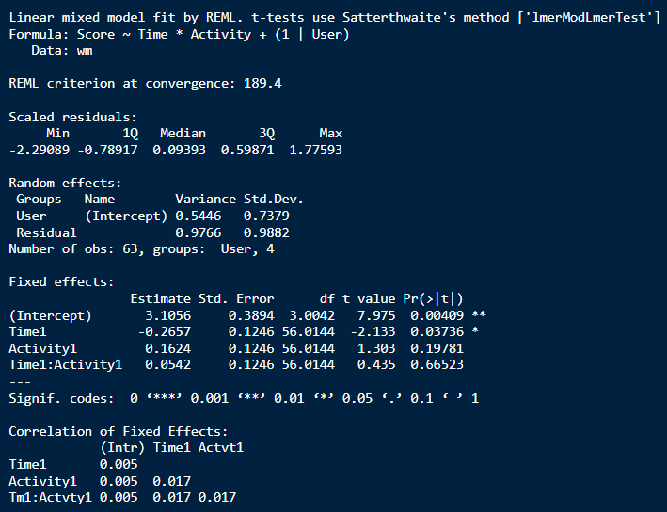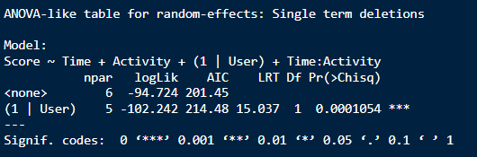

Figure 1: Results from Analysis of the Main Model.

**Conclusions**

The study investigated the effects of activity (walking vs. meditation) and time of day (morning vs. afternoon) on mood change using a 2² factorial design with four participants. The results demonstrated that time of day significantly influenced mood scores, with morning sessions associated with higher mood improvements compared to afternoon sessions. However, neither activity itself nor its interaction with time showed statistically significant main effects. Notably, individual differences (blocking factor "User") were highly significant, indicating substantial variability in mood responses across participants. When modeling team members as random effects, the inclusion of their interactions with activity and time of day improved model fit but introduced complexity, suggesting that personal preferences or habits may modulate outcomes.

Practical Implications:

Organizations aiming to enhance employee well-being could prioritize scheduling mood-boosting activities (e.g., walking breaks, mindfulness sessions) in the morning, given the observed time-of-day effect. While neither walking nor meditation was conclusively superior, the lack of a significant activity effect suggests flexibility—employees could choose based on personal preference. The strong individual variability highlights the value of personalized well-being programs rather than one-size-fits-all approaches.

Limitations:

The study’s small sample size limits generalizability, and the short-term design may not capture long-term mood trends. Self-reported mood scores introduce potential bias, and the artificial experimental setting (e.g., controlled activities) may not reflect real-world behavior. Additionally, the absence of significant interactions between activity and time suggests other unmeasured factors (e.g., noise, workload) might influence outcomes.

Future Studies:

Future research should expand the participant pool to improve statistical power and include diverse demographics. Longitudinal designs could assess sustained effects of activities over weeks or months. Incorporating objective measures (e.g., physiological biomarkers, activity trackers) would reduce self-report bias. Finally, exploring additional factors like noise, social interaction, or workload could uncover moderators of mood change.

*References*

Russell, J. A., Weiss, A., & Mendelsohn, G. A. (1989). Affect Grid: A single-item scale of pleasure and arousal. *Journal of Personality and Social Psychology*, *57*(3), 493–502. <https://doi.org/10.1037/0022-3514.57.3.493>

*Appendix*